Request For Proposal (RFP)
For

Network Operation Center (NOC)
(Video wall system, Hardware & infrastructure)

Directorate Of Cyber Security
& Information Technology

2022

# General Overview and Introduction:
- The directorate of cyber security & Information Technology is planning to establish network operation center (NOC) for a private network in a military unit at Khaw /Zarqa region.
- The dimensions of the hall will be used are (8m X 4m).
- Detailed technical requirements have been specified in the concerned section of this document, and the bidder must adhere at all requirements.
- The Bidder has the right to do the detailed site survey.
# Scope of work of the bidder:
- (3x3) Video wall system.
- Infrastructure including: network cabling, HDMI cabling, electrical works, & Grid from Aluminum tube to install screens (Because there is a prominent column in the wall).
- Wooden frame for the video wall screens.
- Devices including: All-in-one desktop, network switches, 3-in-1 printer, screen & interactive whiteboard.
- Surveillance and access control systems.
- Proposed design is attached at the concerned section of this document.
# Delivery (completion time):
The delivery of the project should be within 4 months, And the receipt will be done one time at the end of the project.

# Documentation:
The bidder shall provide documentation containing as built drawing.
# Technical Specification:
All requirements shall meet the following requirements:
No. | Item | Min. specifications | QTY
1.0 | Video wall system
1.1 | Screen | video wall screen 55" ,4K, UHD, 0.9 mm bezel-bezel width, 24/7 working hours, display colors 16.7 M | 9
1.2 | Wall mount bracket | - Dynamic (push-pull type).  - Must be the same brand of screens. | 9
1.3 | Processor | 4K video wall processor (9 input HDMI / 9 output HDMI) | 1
1.4 | Wooden frame * | Wooden frame to cover the space around the video wall screen (approximately area 4m²) | Lot.
1.5 | HDMI cable | HDMI cable 20m, support 4K | 9
1.6 | HDMI cable | HDMI cable 15m, support 4K | 10
1.7 | HDMI cable | HDMI cable 3m, support 4K | 4
1.8 | HDMI cable | HDMI cable 2m, support 4K | 5
2.0 | Infrastructure
2.1 | Aluminum grid * | - Behind the video wall screens to install screens on it.  - Vertical: aluminum tube 10cmx10cm, Qty: 24 m.  - Horizontal: aluminum tube 8cmx4cm, Qty: 36 m. | Lot.
2.2 | Patch panel | UTP Patch panel 24 ports, Cat6, fully loaded, rack mounted | 1
2.3 | Data cabinet | 42U, 19 “, 600x1000, glass front door, PDU 12 output, 4 fans, 3 shelfs | 1
2.4 | UTP face plates | Complete UTP dual Face plate with connector and all accessories, with external box | 5
2.5 | HDMI outlet | HDMI wall plate, dual, 4K, with external box | 5
2.6 | Plastic trunk | Plastic trunk (2.5x3.8) cm (per m) | 12
2.7 | Plastic trunk | Plastic trunk (5 x 5) cm (per m) | 12
2.8 | Plastic trunk | Plastic trunk (10 x 5) cm (per m) | 12
2.9 | UTP Cable | UTP Cat6 cable (box 305m) (per box) | 2
2.10 | UTP patch cord | UTP Patch cord, Cat 6, 3m | 20
2.11 | power outlet | Dual, MK with external box | 13
2.12 | Power cable | Dual, 1.5 mm (per m) | 250
2.13 | Power cable | Dual, 2.5 mm (per m) | 20
2.14 | Circuit breaker | 16 A, one phase | 5
2.15 | Circuit breaker | 60 A, one phase | 1
2.16 | Circuit breakers box | External, for 6 circuit breakers | 1
2.17 | Power strip | desk mounted, 3 MK outlet, MK plug | 5
3.0 | Network, desktop & peripherals
3.1.0 | Cisco switch WS-C2960CX-8TC-L | 2960-CX Switch 8 GE, uplinks: 2 x 1G SFP and 2 x 1G copper LAN Base | 3
3.1.1 | RCKMNT-19-CMPCT= | 19-Inch Rack Mounting Brackets for 3560-CX and 2960-CX compact switches | 3
3.2 | All-in-one desktop | Core i7, 16 GB RAM, 1 TB HDD, 23”, HDMI output port, original windows 10 and Microsoft office installed, power cable MK plug | 9
3.3 | Printer | Laser printer, monochrome, 3 in 1 (print, copy, scan), Up to 30 ppm (black), media sizes supported: A4; A5; B5 (JIS); A6, power cable MK plug | 1
3.4 | interactive whiteboard | 80” with movable stand | 1
3.5 | IP phone CP-7841-K9= | Cisco IP Phone 7841 | 5
4.0 | Surveillance and access control systems.
4.1 | NVR | 8-ch, 80 Mbps , 2 TB H.D.D | 1
4.2 | Cisco switch SF352-08MP-K9-UK | Cisco SF352-08MP 8-port 10/100 Max-POE Managed Switch | 1
4.3 | IP Camera | Indoor, Dome, 6MP, Lens: 6mm, Frame rate: 25 fps @ 2MP, WDR: yes , PoE | 2
4.4 | IP camera | Outdoor, Bullet, 6 MP, Lens: 6mm, IR distance: 30m, 25 fps @ 2MP, WDR: yes , PoE | 1
4.5 | Monitor | LED 32", Wall bracket, HDMI cable 20m | 1
4.6 | Face recognition Access control system | Complete Access control system (door Lock, access control reader, release button, bypass key switch, software for attendance) | Lot
 | Abroad training
5.1 | CBROPS | Understanding Cisco Cybersecurity Operations Fundamentals. (Instructor-led training). | 3  persons
* It will be more clear after site survey.

# Terms and conditions
1. Tender is one lot and indivisible.
2. Tender contains Supply, installation and integration of all items according to Directorate of Cyber security & information technology requirements in Zarqa region.
3. Offer must include:
A. Technical proposal containing all detailed required specifications with specified Types and models.
B. Compliance sheet containing the requested and the offered specification referring to data sheets, the bidder is responsible for all data in this sheet, not submitting this paper gives the purchasing committee the right to reject the offer.
4. Abroad training:
A. shall Include (tickets, training fee, meals, transportation, full accommodation, visa … etc).
B. should be held via certified Training Center and certified trainer.
5. The bidder should adhere of all above specifications and conditions.

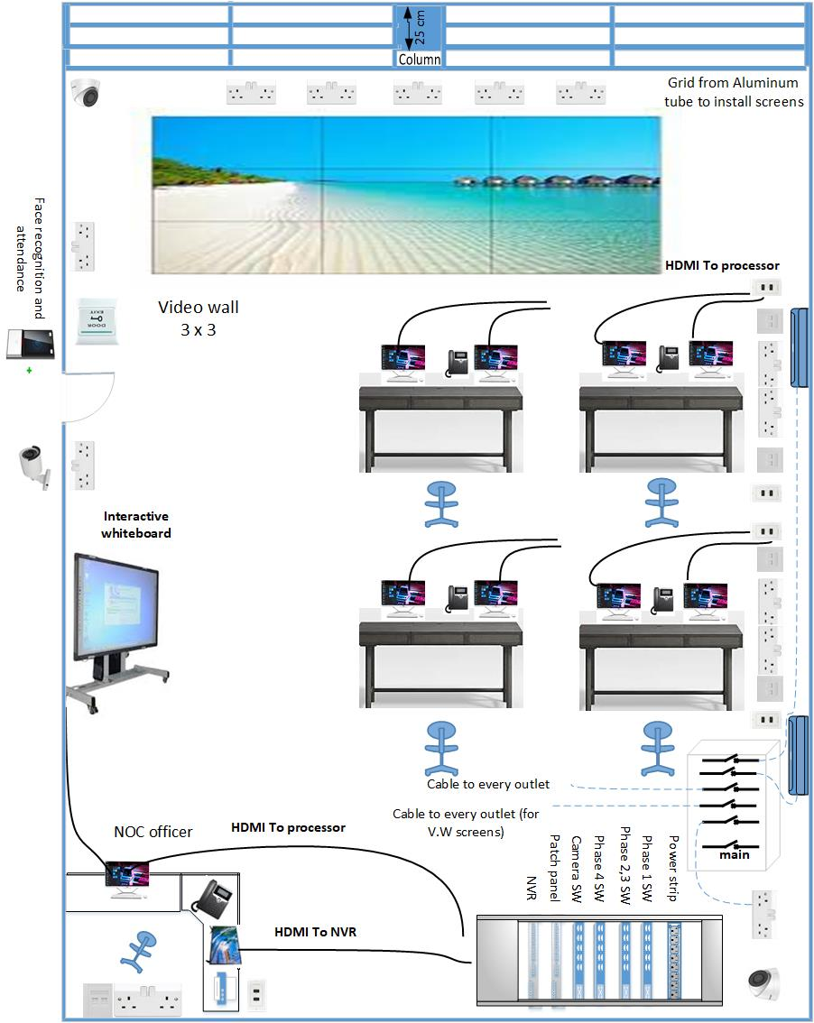
Proposed design

